Computer Workshop 3: Linear models with a continuous predictor
Roos & Pinard
Last updated: 2025-09-05
Table of Contents

Workshop Structure
As always, we are using the workflow below to structure the workshops:
- Formulate a research question.
- Perform exploratory data analysis.
- Identify any hidden assumptions.
- Fit an appropriate model [Focus of today].
- Diagnose the model and check assumptions.
- Summarise the results.
- Interpret and provide inferences.
However, starting this week, we’ll start by applying this entire workflow to a single dataset for a more integrated experience, before giving you a new dataset to work through independently.

1. Formulate a Research Question
For this first workshop on linear models, we’ll use a dataset introduced in a previous workshop to start with something familiar: the boto.txt dataset from Workshop 2. Here’s a reminder of what’s included in the dataset:
- sex: The sex of the boto dolphin.
- drought: The number of years out of the past 20 where drought was observed in the region where the dolphin was recorded.
- length: The length of the boto dolphin (in cm).
For this analysis, we aim to determine whether the number of droughts in the past 20 years affects the length of boto dolphins. The broader context for this question lies in concerns that droughts may become more frequent in parts of the Amazon basin due to climate change and dam construction. In other words, if droughts increase, could boto dolphins become smaller and potentially be in poorer condition?
From this, we know two things: - The response variable is length. - The predictor variable (also known as the explanatory variable or covariate) is drought.
In essence, we want to understand how length changes as drought varies.
Before proceeding, it’s crucial to consider whether the data-generating process for boto length (i.e., all factors influencing dolphin size) can be reasonably approximated by a $Normal$ distribution. Specifically, we’re asking:
$$length_{i}∼Normal\left(μ_{i},σ\right)$$
where $length_{i}$ represents the length of dolphin $i$, which we assume follows a $Normal$ distribution with a mean of $μ_{i}$ (the model’s predicted length for dolphin $i$) and a standard deviation of $σ$.

Assessing the Normal Distribution Assumption
To decide whether assuming a $Normal$ distribution is reasonable, we start by asking if length is continuous or discrete. A discrete variable could only take integer (or whole numbers) values like 1 cm, 2 cm, etc. Phrased alternatively, we could never have a dolphin that was 270.1 cm. It would either be 270 or 271 cm. In contrast, while our data are rounded to the nearest centimeter, the actual lengths of the dolphins aren’t constrained to such increments; length is inherently continuous. A $Normal$ distribution is appropriate for generating continuous values (though there are others). To see this visually, you can run the following code which uses rnorm(), or “randomly generate n values from a $Normal$ distribution”:
rnorm(n = 10, mean = 200, sd = 10)
After running the code, you’ll notice that the simulated values look pretty similar to the length of our boto dolphins, suggesting that a $Normal$ distribution is a good fit in this respect (note we’re only using rnorm() here for demonstration purposes, you wouldn’t really do this in a formal analysis). The only difference between the rnorm() values and the actual length measurements we have is that the researchers seem to have rounded their length measurements.
Next, we should ask if there are any natural bounds on the data and whether our model might predict values near these bounds. For boto length, the natural lower bound is zero — i.e. no adult animal can be 0 cm long. Although this suggests that a $Normal$ distribution could theoretically predict impossible (negative or zero) lengths, the minimum observed length in our data is well above zero. Therefore, the risk of the model predicting such extreme values is minimal.
In practice, this makes a $Normal$ distribution a reasonably safe choice here. However, we should still check the model’s predictions later to ensure it isn’t producing values that are physically implausible. If the model predicts the impossible, then we’d switch to another distribution using a “Generalised” Linear Model (or GLM). We’ll cover GLMs at the end of the course.

Important Clarification
Working through the process of selecting an appropriate distribution might feel overwhelming when you’re new to statistics. However, with experience, these decisions become intuitive and can often be made in a matter of seconds.
Note: Deciding which distribution to use is entirely distinct from the assumption of normality in linear models, formally known as the assumption of “normally distributed errors” (or sometimes “normally distributed residuals”). The choice of distribution is a consideration based on the nature of the response variable, and you can make this decision before even examining the dataset.

Question Set One
- Does a $Normal$ distribution generate discrete or continuous values?
- Using rnorm(n = 100, mean = 50, sd = 20), what’s the smallest value you generate when running it? Try changing the standard deviation (sd =) to see what impact this has.
- If the values generated by rnorm(n = 100, mean = 50, sd = 20) were your response variable, would it be reasonable to assume a $Normal$ distribution in your analysis?
- If your data is generated according to a $Normal$ distribution, does that mean you have met the assumption of Normality?

2. Perform Exploratory Data Analysis
Since you’ve already worked with this dataset in a previous workshop (this is the same data you used to learn ggplot2 and data visualisation, which is a key part of getting to know your data set), we can skip the exploratory data analysis (EDA) step in today’s workflow. However, if you’d like a refresher, you can either continue using the script from Workshop 2 or copy and paste the relevant EDA code into your new script for today.

3. Identify Any Hidden Assumptions
Before we proceed, take some time to think about the various assumptions we’ll be making when using this dataset for modeling. If you need a reminder of what the assumptions are, they’re included at the end of this document.
Consider whether we are likely to break any of these assumptions based on your understanding of the data and your exploratory data analysis (EDA).

Question Set Two
- Which assumptions do you believe are very likely to be violated?
- Which assumptions could we check after fitting the model?

4. Fit an appropriate model.
Now that we’ve gone through the preliminary steps, it’s time to dive into the actual statistics. We’re going to fit a linear model of the form:
$length_{i}∼Normal\left(μ_{i},σ\right)$
$μ_{i}=β_{0}+β_{1}×drought_{i}$
Where:
- $length_{i}$ is the length of dolphin $i$, assumed to follow a $Normal$ distribution with a mean of $μ_{i}$ (what the model predicts for dolphin $i$) and a standard deviation of $σ$.
- $μ_{i}$ represents the linear relationship between $drought_{i}$ (the number of drought years) and dolphin length, defined by two parameters:
  - $β_{0}$: The intercept of our line (how long we expect a dolphin to be when the number of droughts is zero).
  - $β_{1}$: The slope (how much $length$ is expected to change for each additional year of drought).
If you need a refresher, feel free to go back to the lecture slides or recording.
That’s the conceptual model. But how do we translate that into some R code? It’s pretty straightforward, and we can also store the model output so we can use it again later on without having to rerun the model each time. Here’s how we do it:
boto_model <- lm(length ~ drought, data = boto)

Mapping the Equation to the Code
Here’s how the mathematical model corresponds to the R code:
- lm() tells R that we are fitting a linear model, which, by default, means that we assume the response variable follows a $Normal$ distribution.
- The formula length ~ drought represents the relationship we’re modeling. In mathematical terms, this corresponds to $μ_{i}=β_{0}+β_{1}×drought_{i}$. The length variable is our response (sometimes called the “dependent”) variable, and drought is our predictor (or “independent” or “explanatory”) variable.
Now, let’s get to the interesting part: what does the model tell us? We can use the summary() function to see the results and interpret what the model says:
summary(boto_model)
When we run the summary() function on our model, we get a lot of information, but for starters, we are particularly interested in the Estimates section. From this, we can see the estimated values for $β_{0}$ and $β_{1}$: 213.281 and -5.308, respectively. But what do these values mean?

Parameter Meanings
When we wrote out our equation above, we said “$β_{0}$: The intercept of our line (how long we expect a dolphin to be when the number of droughts is zero)” and “$β_{1}$: The slope (how much $length$ is expected to change for each additional year of drought)” but why is that? How do we know what these parameters means? To show you how you can do this, let’s revisit our model equation, where we’ll start by figuring out what the intercept is:
$μ_{i}=β_{0}+β_{1}×drought_{i}$
$drought_{i}$ is whatever value drought is for row $i$ of our dataset. As a thought exercise, imagine a scenario where there has never been a drought, and $drought=0$. In this case, the equation becomes:
$μ_{i}=β_{0}+β_{1}×0$
Because any number multiplied by zero becomes zero, we can simplify this to:
$μ_{i}=β_{0}$
And we’re left with $β_{0}$. This is why $β_{0}$ represents the estimated length of boto dolphins when there has been no drought. And according to our model, the intercept value is 213.3 cm. So, if no droughts have occurred, the model predicts that dolphins would be approximately 213.3 cm long. This is why the intercept is often described as “the value of $Y$ when $X$ is equal to zero”.
If $β_{0}$ represent the length of botos when drought is zero, then $β_{1}$ must be the value that describes how much the length of the dolphins changes with each additional year of drought. From our model summary, $β_{1}$ is -5.308. This means that for each additional year of drought, the length of an average dolphins decreases by roughly 5.3 cm.
So if we were to draw a line, we’d start at $drought=0$ and $length=213$, then for every additional year (or a “unit increase”) $length$ would reduce by 5.3.
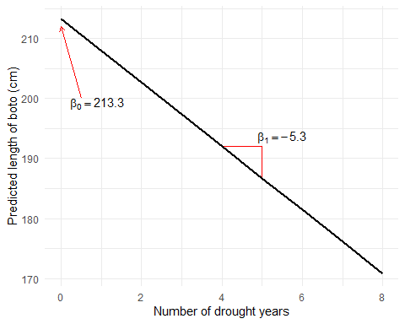
And that’s it! All the actual statistics we need has been run and summarised in just two lines of code using lm() and summary(). What now?

Question Set Three
- Replace the blank areas of the equation with the values that have now been estimated by the model.
$length_{i}∼Normal\left(μ_{i},σ\right)$
μi=β0+β0×droughti
- Using your completed equation from 1., what value of $μ$ (or boto length), would you predict if there had been zero years of drought?
- Using your completed equation from 1., what value of $μ$ (or boto length), would you predict if there had been eight years of drought?
- What would you predict the difference in length be for a boto that had experienced two years of drought, and another than had experienced seven years of drought?

5. Diagnose the model and check assumptions.
We’ll cover this on Friday.

Extra: How many decimal points?
Generally, when we work with summaries of data and estimates, these won’t be integers (i.e. whole numbers, 1, 2, 3) but will be floating numbers (i.e. numbers with decimal points, 1.1, 2.032, 3.14). A common question is, “How many decimal points should I use and report?” There is no singularly correct answer. It depends on context. For example, in the next step of this workshop you’ll be using parameter estimates to create figures showing your predicted relationship. If you were to do this by hand, should you use zero decimal points or one hundred? Let’s see what difference it makes with a hypothetical model.
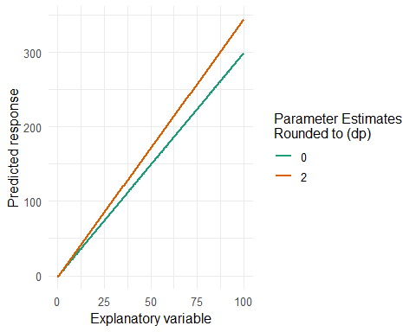
In the figure above, the parameter estimates from the model ($β_{0}\left(\text{Intercept}\right)=−1.23456789$ and $β_{1}\left(\text{Slope}\right)=3.45567891$) have been rounded to zero or two decimal places. For zero decimal places, this becomes ($β_{0}\left(\text{Intercept}\right)=−1$ and $β_{1}\left(\text{Slope}\right)=3$) and for twop decimal places ($β_{0}\left(\text{Intercept}\right)=−1.23$ and $β_{1}\left(\text{Slope}\right)=3.46$), resulting in fairly different lines being drawn here. This isn’t great, because an arbitrary decision is having an impact in how we understand the system. We can see a more extreme (but not uncommon) example below.
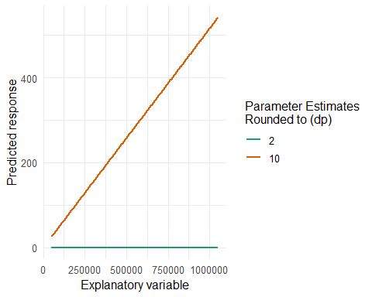 Note that in the above figure the explanatory variable values are much larger than the first example. Here we’re going up one million “explanatory variable units” (whatever this might be, e.g. CO2 emmissions), which means that our parameter estimates are, in this case, tiny; $β_{0}\left(\text{Intercept}\right)=0.0000000652$ and $β_{1}\left(\text{Slope}\right)=0.0005161519$. Meaning that when we round these two two decimal places, we get $β_{0}\left(\text{Intercept}\right)=0.00$ and $β_{1}\left(\text{Slope}\right)=0.00$.
So in the first example, rounding to two decimal points is perfect. In the second, it’s terrible. The point here is that when you round numbers for a something like a report or thesis, then you need to think about it. How much does the number change if I round to zero decimal points? What about to five decimal points? What is the range of the explanatory variable? Does it go to billions, or just a handful? All of these are important features to consider, particularly when working with parameter estimates.
In the tests for BI3010 we will always state how many decimal points you should report values to.

6. Summarise the results.
We’ll come back to “5. Diagnose the model and check assumptions.” on Friday. For today we’ll go through how to take these results and convert them into a figure.
To do so we’ll show you two options.
- Option 1: Use an R package to create the figure for you.
- Option 2: Create the prediction and figure yourself.
Option 1 is nice because it’s really quick and easy. The downside, though, is that you don’t get much control in what the figure looks like, and these packages can often obscure what’s going on, leading to confusion (e.g. “How did you make this figure?”. shrug.).
Option 2, on the other hand, can be more fiddly, but has the benefit of giving you flexibility, and makes the underlying process pretty transparent.
We’ll start with Option 1.

Use an R package to create the figure for you.
First, install a package called ggeffects:
install.packages("ggeffects")
As with other R packages, once it’s installed on your machine you shouldn’t need to install it again. When it’s finished loading, make sure to load it:
library(ggeffects)
Next, we’re going to use a function within ggeffects to create predictions from our model which we’ll store in a new object called preds (or whatever you prefer to call it), which we’ll plot subsequently. This is where storing the model output becomes really handy:
preds <- ggpredict(boto_model)
Now we just need to plot it:
plot(preds)
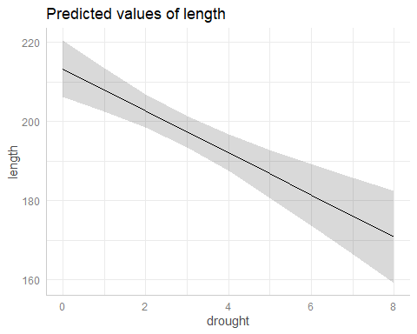
And there we have it - with 95% confidence thrown in as a bonus! (We’ll cover 95% CI and what they mean next week). As easy as that. Buuuuut…. there are stylistic choices that I, personally and subjectively, don’t like. I wanna decide what’s going on, not some automated software!

Create the prediction and figure yourself.
It’s actually not much harder to make the figure ourselves. We’ve actually already learnt all of the techniques we need to do so. Let’s get to it.
For starters, we’re going to make a fake dataset. This dataset is going to contain, initially, just one variable; drought, and we’re going to keep it as simple as we can. We just want drought values of 0, 1, 2, 3, 4, 5, 6, 7 and 8. We can create this kind of data super easily in R using 0:8. Try entering 0:8 in the console to see what it does, if you’re unsure. To create the fake dataset we use the data.frame() function. Bringing this all together, we get:
fake <- data.frame(
drought = 0:8
)
In Question Set Three, you specified values of drought and used your equation to predict boto length by hand. What we’re going to do next is exactly the same, we’re just going to be “lazy” and have R do it for us using the predict() function. To be clear, it’s doing exactly the same thing you did; just taking a value of drought and predicting boto length. As with ggeffects we say what the model was, but we’re also going to tell predict() to use a new dataset to make the predictions; our fake dataset. We’re then going to add these predictions into the fake dataset to make plotting easier for us.
fake$fit <- predict(boto_model, newdata = fake)
Now we have a dataset that contains all values of drought we’re interested in, as well as the predicted length (called fit in my code above). So we have a dataset (fake) and we want to make a plot. You guys know how to do this, using ggplot2!
ggplot(fake) +
geom_line(aes(x = drought, y = fit)) +
labs(x = "Number of drought years",
y = "Predicted length of boto (cm)",
title = "Estimated association between boto length and drought") +
theme_minimal()
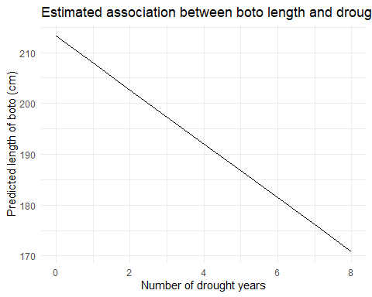
The full process here, from loading a dataset to getting a figure that enables us to see the association between drought and boto length can be done in a surprisingly few lines of code. Here’s my how I’d code this:
# Deon Roos
# Analysis of boto length in relation to droughts
# Load data
setwd("my/file/path")
boto <- read.table("boto.txt", header = T)
# EDA
summary(boto)
str(boto)
ggplot(boto) + geom_point(aes(x = drought, y = length))
ggplot(boto) + geom_point(aes(x = drought, y = length, colour = sex))
ggplot(boto) + geom_point(aes(x = drought, y = length, colour = sex)) + facet_wrap(~sex)
# No weird observations detected in EDA
# Concerns prior to modelling
# Measurement of botos is very accurate - unsure how this was measured
# Validity - depending on how measurement was taken
# Independence - seems like that families would be measured
# Additivity - drought may impact sexes differently
# Analysis
boto_model <- lm(length ~ drought, data = boto)
# Diagnostics
# Covered in next workshop
# Inference
summary(boto_model)
fake <- data.frame(drought = 0:8)
fake$fit <- predict(boto_model, newdata = fake)
ggplot(fake) +
geom_line(aes(x = drought, y = fit)) +
labs(x = "Number of drought years",
y = "Predicted length of boto (cm)",
title = "Estimated association between boto length and drought") +
theme_minimal()
The entire workflow is done in about 40 lines of code and about a quarter of that is comments. More importantly, the entire analysis of this dataset is done responsibly, with useful (in my mind) comments, and is now saved in a script such that I can share this with anyone who might want to see it. That last point is a big one. As mentioned previously, there are scientists out there who routinely fake data. Being able to provide a script which clearly demonstrates every step you took in a piece of analysis is a huge help in detecting those kinds of issues. Indeed, I’d recommend attaching your R scripts as an appendix when you submit your Honour’s project, not because the reviewers will go through it in any amount of detail, but simply to instil some good research practices.
As a tip, don’t confuse the length of a script with complexity or the intelligence of the coder. When I did my Honour’s project, my R script had something like 1,000 lines of code. It wasn’t because I was doing anything particularly complicated (my analysis was more or less equivalent to the model you just ran) but because I didn’t really know what I was doing, so I threw everything I could find at it. Often less is more in coding.

A new challenger
Using the skills you’ve just developed, you’re now going to analyse an entirely new dataset, the beetles.txt dataset on MyAberdeen. This data comes from a lab experiment from researchers who were interested in understanding how temperature impacts fecundity in burying beetles (Nicrophorus vespilloides), ultimately attempting to understanding how short term (i.e. 6 hours) exposures to temperature changes may affect how the species may respond to climate change.
The data contains:
- offspring - the number of offspring produced by the beetles
- temperature - the temperature at which the beetles were exposed to for 6 hours a day
Using this data, carry out an EDA, consider which assumptions are likely violated, determine an appropriate model and fit it, then plot the results.
You can go about this in any manner you deem appropriate but keep in mind that we may ask you to analyse an equivalent dataset in a Quiz, so make sure you are comfortable with the workflow.
If you don’t manage to finish, don’t worry, we’ll return to these models on Friday.

Assumption table
Assumption | Description | Example of Violation
1. Validity | The data is able to answer the research question effectively. | Using IQ to measure overall intelligence (what does IQ even measure?).
2. Representativeness | The data reflects the population or group being studied. | Using survey data from a rural area to draw conclusions about an urban population.
3. Additivity | Effects of predictors are additive and there are no interactions between them. | Assuming that study hours and sleep hours independently affect exam scores without considering their combined effect (imagine a Venn diagram with study and sleep overlapping).
4. Linearity | The relationship between predictors and the outcome is linear. | Assuming plant growth will continue to increase indefinitely without ever levelling out.
5. Independence of Errors | Observations are independent of each other. (Related to residual errors.) | If modelling height, the data come from the same group of children over time.
6. Equal Variance of Errors | Residuals have constant variance across all levels of predictors (“homoscedasticity”). (Related to residual errors.) | If modelling income, variability in salaries is not the same across all levels of a company’s hierarchy.
7. Normality of Errors | Residuals should be normally distributed. (Related to residual errors.) | If modelling income, the presence of any extremely wealthy individuals will be hard for the model to understand and explain.

